
Solution Architecture

Date | 06 July 2026
Team ID
Project Name | Flood Prediction System
Maximum Marks | 5 Marks

Solution Architecture Diagram:
Provide a high-level visual representation of your solution's architecture. Use the structural layout below as a template to map out your Presentation Layer, Application Layer, and Data Layer. Fill in the specific technologies and components for your project directly into the boxes to create your architectural diagram.

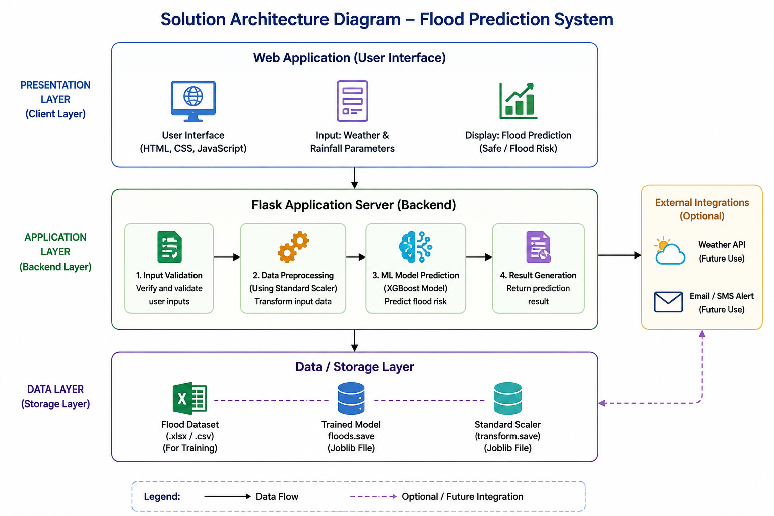


Component Description Table

Component Name | Description / Role in Architecture | Technologies Used
Presentation Layer | Collects rainfall and weather details from the user and displays the prediction result. | Flask, HTML, CSS, JavaScript
API Gateway | Receives user requests and forwards them to the prediction service. | Flask
Core Logic Service | Validates input, preprocesses data using the Standard Scaler, and predicts flood risk using the XGBoost model. | Python, Scikit-learn, XGBoost, Joblib
Data / Storage Layer | Stores the flood dataset, trained machine learning model, and scaler used for prediction. | Excel Dataset (.xlsx), floods.save, transform.save

